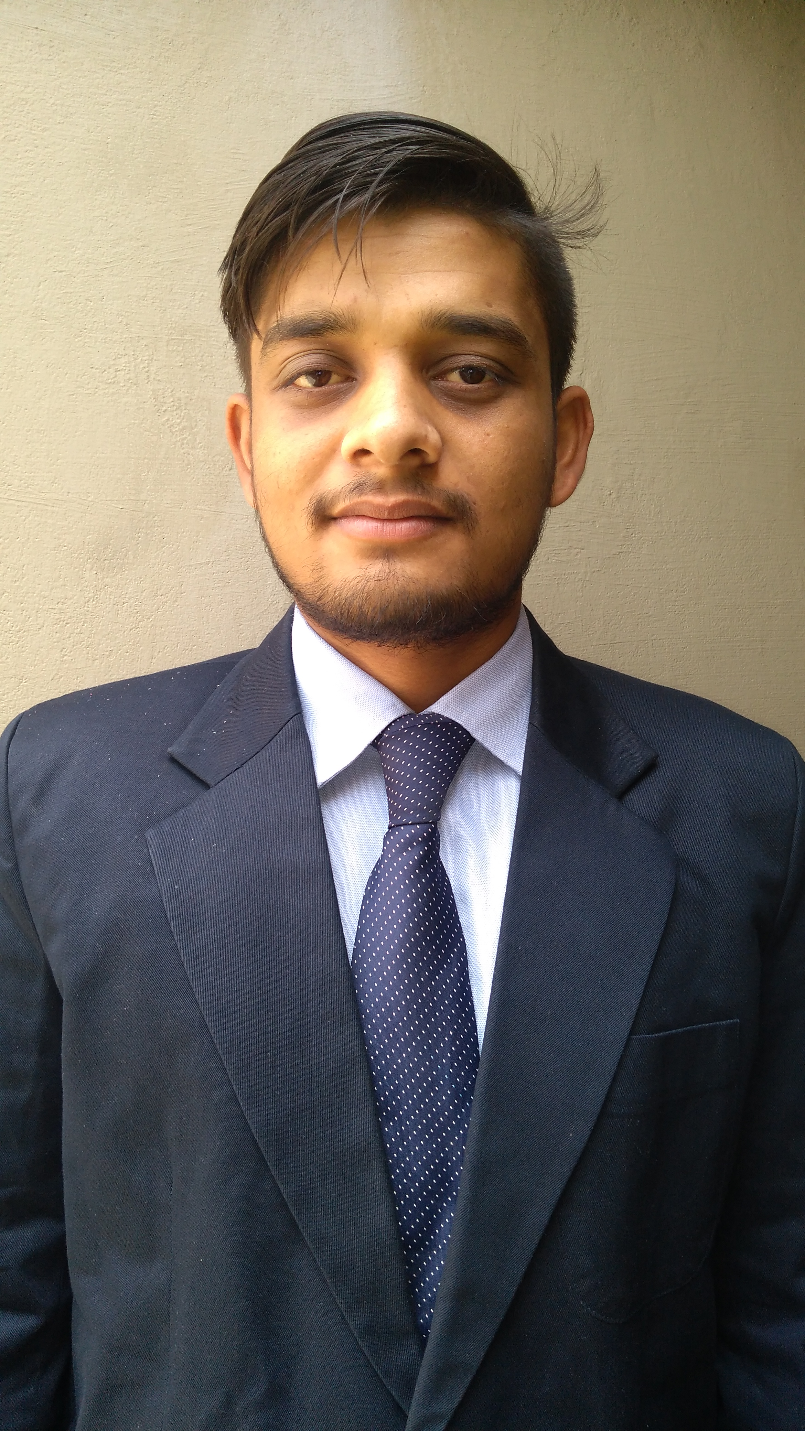

ashish kumar mishra
Contact no:+91+72638+81824,8788612632
Address:- A69 Qutub Vihar Hanuman Chowk New Delhi (110071)
Email ID:-ashishkumarmishra146@gmail.com

CAREER OBJECTIVE: - I am looking for an opportunity in a reputed organization which will help me deliver my best and upgrade my skills in engineering and meet the demands of the organization.

MY STRENGTHS:
- Leadership skill
- Quick learner
- Adaptable
EDUCATIONAL QUALIFICATIONS:
Degree | Institute | Board/University | Year  Of  passing | Percentage/SGPA
B.E | Priyadarshini Indira Gandhi college of Engineering Nagpur | RTMNU | 2018 | 8.61 SGPA
Diploma | Somayya Diploma in Engineering Chandrapur | Maharashtra | 2015 | 73.00%
S.S.C | Rastriya Vidya Peeth Inter College Pithla Faizabad, U.P | Uttar Pradesh | 2011 | 63.83%
Computer skills & software proficiency
- Asp.Net(Visual Studio2012,2015,2017)
- C#
- SQL Server (2008,2010,2014)
- HTML
- CSS
- JAVA Script
- Jquery
- Web Api
- Basic of MVC(version 4 ,5 )
- Work With TFS Server
Technical Project
Project: - 1.B.E Project (Automatic Metro train Shuttle between two station)
2. Diploma Project (digital survey system)
Project based on ASP.NET
1….Name .(ERP System (Stock, Payroll,) Jaguar Security Service Pvt. Ltd
Environment (Visual Studio 2012 SQL Server 2014)
Description: This Project is based on (N tier Architecture)ASP.NET and application of this project is Managing stock of all India branches and making guard and staff salary through this (payroll) software
2…. Name. .(ERP System (Stock, Payroll, Billing,) Pro Align Security Pvt. Ltd
Environment (Visual Studio 2015 SQL Server 2014)
Description: This Project is based on (N tier Architecture)ASP.NET and application of this project is Managing stock of all India branches and making guard and staff salary with GST and all government deduction like (LWF) through this (payroll) software
TRANNING AND INTERNSHIP
- Naresh I Technologies Hyderabad (ISO 9001:2008)
- 3 Month Training In Microsoft.Net With MVC
- 1 year experience as a full stack developer
- Working in Canticle Technologies PVT.LTD New Delhi
EXTRA CURRICULAR ACTIVITIES:
- Participated in various technical events in (B.E)
- Participated in various sport events
HOBBIES:-
- Playing cricket, badminton, football and volleyball.
ACHIEVENTS
- 1st Prize in project exhibition 2015
- 1st Prize in B.E project exhibition(Inovesta) 2018
- 1stWinner of volleyball(M.S.B.T.E Sports Meet)
GENERAL PROFICIENCY:-
- Interested in playing cricket
- Listening songs
PERSONAL DETAILS:
- Father’s Name : Ravichandra Mishra
- Mother’s Name: Bhanumati Mishra
- Date of Birth:-11th JUNE 1997
- Languages Known: English, Hindi, Marathi.

DECLARATION:
I, the undersigned hereby declare that the above given information is true to the best of my knowledge.
Date:
Place: Delhi ASHISH KUMAR MISHRA

